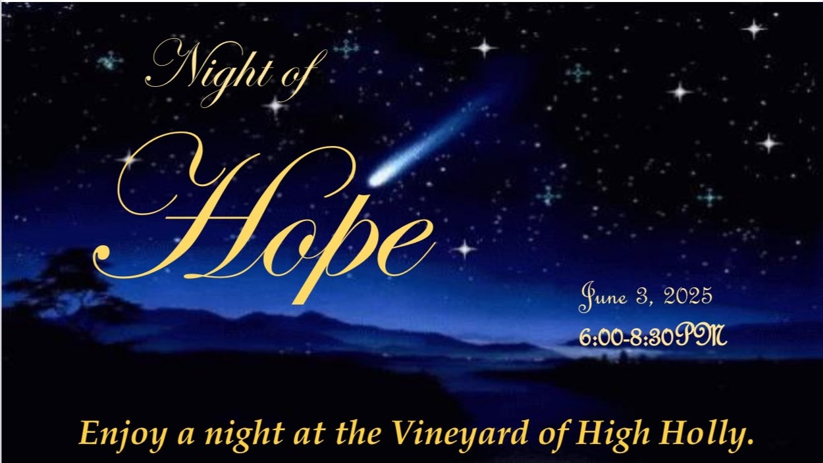

This evening will include dinner, a fashion show for men and women (Indigo) all to the music of Eli Mosley, Country Music Artist.
This wonderful evening will benefit the Sid Weber Memorial Cancer Fund, and Mary Kay Ash Cancer Research Foundation
Cost is $125 per person or join with me as a sponsor. (Sponsorships start at $1200.)
If you are unable to attend donations are welcomed. Please contact me with any questions you may have.
Barbara Anderson - 561-281-8578 or email: bande100@bellsouth.net
Make checks payable to ''Sid Weber Memorial Cancer Fund'' Note it is for ''Night of Hope''
Vineyard of High Holly- 37 High Holly Road, Scaly Mountain, NC Mail checks to Barbara Anderson 646 Winding Ridge Dr. #431
Sky Valley, GA 30537

